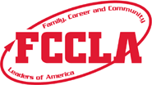  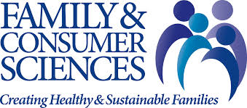 | Utah FCCLA State Conference  Davis Conference Center  762 W. Heritage Park Blvd.  Layton, Utah 84041  March 24-25, 2020

Get your hotel rooms today!

All conference forms are on the Utah FCCLA website under the conference tab. www.utahfccla.org

Be working on your 4 Star Chapter Applications.

Look forward to seeing you at State Conference!

TENTATIVE AGENDA
2020
UTAH FCCLA STATE LEADERSHIP & RECOGNITION CONFERENCE
Times may change – see final conference program available on the Utah FCCLA app to confirm times.

DATE/TIME ACTIVITY
MONDAY, MARCH 23
7:00 pm – 10:00 pm Conference Packet Pick-up
4:00 pm – 8:00 pm State and National Officer Candidate Interviews
4:00 pm – 8:00 pm State and National Officer Candidate Test

TUESDAY, MARCH 24
7:30 am – 8:20 am Conference Packet Pick-up & Registration
8:00 am – 8:30 am Mandatory STAR Event Sign In
8:45 am – 10:00 am OPENING GENERAL SESSION (includes keynote speaker)
9:00 am – 9:30 am Room Consultants Meeting
9:40 am – 10:00 am Evaluators Check-in & Orientation
10:10 am – 10:30 am Students attend Region Meetings
10:30 am – 3:00 pm STAR Events Competitions
11:00 am – 1:00 pm FCS Assessment Testing
11:30 pm – 2:00 pm Delegates cast votes in testing center
10:00 am – 3:00 pm Service Project Activity
10:00 am – 4:00 pm FCCLA Expo Interactive Exhibits Open
10:00 am – 3:00 pm Workshops
4:00 pm – 5:30 pm AWARDS SESSION
6:00 pm – 7:30 pm Dinner (on your own)
8:00 pm – 10:30 pm State Activity “Adventure Party”
11:00 pm

WEDNESDAY, MARCH 25
8:30 am Star Recognition Check-In
9:00 am – 12:00 pm Closing Recognition Session
12:00 pm – 1:15 pm National Leadership Conference Information Session
All 1st and 2nd place winners and their advisers, and newly elected State
and National Officers and their advisers must attend.

