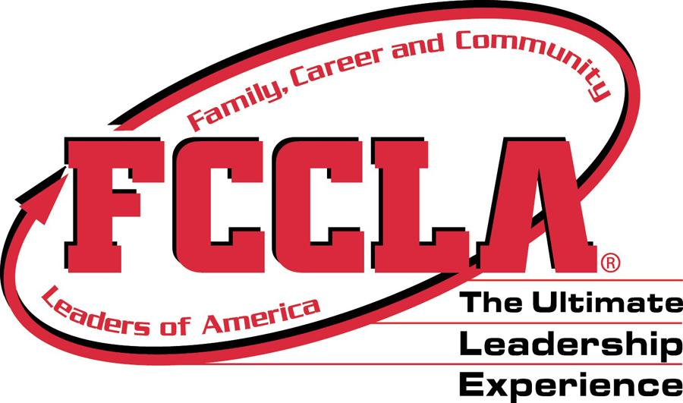 Utah FCCLA Calendar of Events/Deadlines 2022-2023
ALL DATES ARE SUBJECT TO CHANGE

Month | Events | Deadlines
August 2022 | *4 – New Adviser Training
September 2022 | *Membership Drive  *28- Fall Leadership – Provo, Utah Valley Convention Center | In order to register for Fall Leadership you must affiliate your officers with National FCCLA @ fcclainc.org  *16-Fall Leadership registration closes  *16- Fall Leadership payment postmarked
October 2022 | *TBD-Region Activities  *9-12 - National FCCLA Capitol Leadership Washington, DC
November 2022 | *TBD -Utah FCCLA Jazz night
December 2022 | Be working on STAR Events
January 2023 | Be working on STAR Events | *Region Conference online registration/payment postmarked deadlines (check with Region Adviser)
February 2023 | *7-Region 5 Conference; Southern Utah University  *16-Region 1 Conference; Weber State University  *TBD-Region 2 Conference; BYU  *10-Region 4 Conference; Nebo Summit Center  *1-Region 3 Conference; Lone Peak High  *13-17 - FCCLA Week | *1-Affiliation due to National FCCLA to compete in Region STAR Events or run for state office.
March 2023 | *21-22- State Conference, Layton, Utah | *1-State Conference online registration closes  *1- State Conference payment postmarked due to Karen Atkin:  - Utah FCCLA 4 Star Chapter Application  - Utah FCCLA State Goals Application  - Utah FCCLA Adviser Awards  - Utah FCCLA Chapter Member/Officer Awards  - National School Administrator of the Year Application  - National STAR Events Volunteer Application  - Utah FCCLA Scholarship Applications  - State Officer Applications  - Power of One Applications  - Master Adviser Applications  - Adviser Mentor Applications  - National FCCLA Honorary Membership Application  - National FCCLA Distinguished Service Application  - National FCCLA Integration of Core Academics Application  *1 All postmarked due to National FCCLA  National Program Award Applications
April 2023 | *TBD - New State Officer Training | *17-Postmarked NLC Paperwork, Survey and $300 down Payment
May 2023 | *Registration due for National FCCLA.  *TBD- Potential Lagoon Day | *1-Postmarked NLC Final Payment Due
July 2023 | *July 1-6 FCCLA National Leadership Conference, Denver, CO

