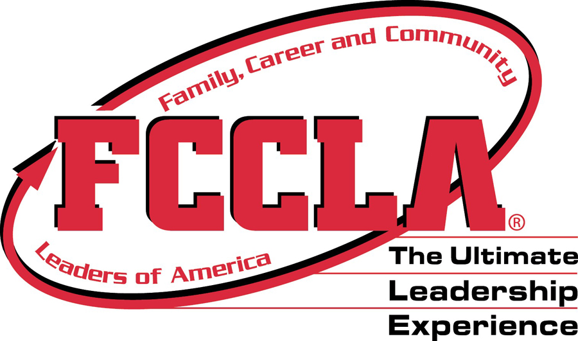 Utah FCCLA Calendar of Events/Deadlines 2021-2022
ALL DATES ARE SUBJECT TO CHANGE

Month | Events | Deadlines
August 2021 | *4 – New Adviser Training
September 2021 | *30- Fall Leadership – Provo, Utah Valley Convention Center | In order to register for Fall Leadership you must affiliate your officers with National FCCLA  *17-Fall Leadership online registration closes  *17- Fall Leadership payment postmarked due to Nikki Sue
October 2021 | *TBD-Region Activities
November 2021 | *3-6 – National FCCLA Fall Conference, Washington, DC  *TBD -Utah FCCLA Jazz night
December 2021 | Be working on STAR Events
January 2022 | Be working on STAR Events | *Region Conference online registration/payment postmarked deadlines (check with Region Adviser)
February 2022 | *1-Region 5; Southern Utah University  *3-Region 1 Conference; Weber State  *TBD-Region 2 Conference; BYU  *TBD-Region 4 Conference; BYU  *TBD-Region 3 Conference; BYU  *14-18 - FCCLA Week | *1-Affiliation due to National FCCLA to compete in Region STAR Events or run for state office.
March 2022 | *22-23- State Conference, Layton, Utah | *1-State Conference online registration closes  *1- State Conference payment postmarked due to Nikki Sue  *1 All postmarked (mailing or electronic) due to Nikki Sue:  - Utah FCCLA 4 Star Chapter Application  - Utah FCCLA State Goals Application  - Utah FCCLA Adviser Awards  - Utah FCCLA Chapter Member/Officer Awards  - National School Administrator of the Year Application  - National STAR Events Volunteer Application  - Utah FCCLA Scholarship Applications  - State Officer Applications  - Power of One Applications  - Master Adviser Applications  - Adviser Mentor Applications  - National FCCLA Honorary Membership Application  - National FCCLA Distinguished Service Application  - National FCCLA Integration of Core Academics Application  *1 All postmarked due to National FCCLA  National Program Award Applications
April 2022 | *TBD - New State Officer Training | *16-Postmarked NLC Paperwork , Survey and $300 down Payment
May 2022 | *TBD- Lagoon Day | *1-Postmarked NLC Final Payment Due
June 2022 | *June 27 – July 3- FCCLA National Leadership Conference, San Diego, CA

