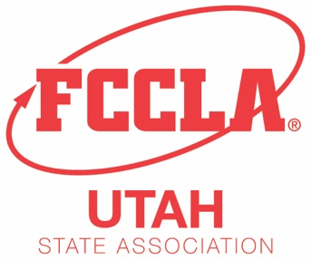
2020 Utah FCCLA Fashion Show

Application and Consent Form

Please type information below:

Participant Name: Grade:

Phone: Email:

School:

FCCLA Advisor Name:

STAR Event Registered for:

Project Title:

Name of Model:

2-4 sentence description of design to be read by the host during the Fashion Show:

Guidelines
- Fashion Show will be during the 2nd General Session in the afternoon of March 24.
- All entries must be a STAR Event participant in either Fashion Construction, Fashion Design, or Recycle/Redesign at the 2020 Utah FCCLA State Leadership Conference.
- Only the participants (and models) are allowed in the setup area. Other persons may not assist. Participants must bring all necessary supplies and/or equipment to preparation time.

I agree that the garment will be an expression of my own ideas and work. I further give permission for Utah FCCLA to display my design during the FCCLA Fashion Show, on the FCCLA Web site, and in photographs used for promotional purposes.

Date: ___________________ Participant Signature: ______________________________

I give permission for this student to participate in the Utah FCCLA Fashion Show at this year's State Leadership Conference. I certify that the student has read and understands all guidelines of this show and that he/she will abide by them.

Date: ___________________ Advisor Signature: _________________________________

Email or Fax this completed application form to Nikki Sue Larkin, utahfccla@gmail.com by March 2, 2020.

