2018-2019
“Discover You”
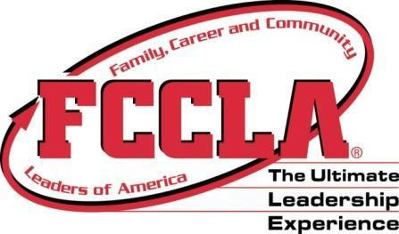
Utah FCCLA State Goals Award Application
Theme | Discover You

Goal | Challenge
Bucket List Award | - 50% of your affiliated members complete Power of One National Program.
Carry On Award | - Complete 3 membership recruitment activities in your school.
International Travel Award | - Complete a service project with another school organization.
Pilot Award | - Complete and submit the National Program “Career Connections”.
Travel Guide Award | - Invite a state officer to a chapter meeting or activity.
Passport Award | Complete and submit documentation for all five Star awards by March 1, 2019 and receive the Passport Award. Award winners will be recognized at the 2019 Utah FCCLA State Conference.

Please list the ways that your chapter has met the 2018-2019 State Goals in each area. Submit any necessary documentation.

- Bucket List Award: 50% of your affiliated members complete the Power of One national program.
- Carry On Award: Complete 3 membership recruitment activities in your school.
- International Travel Award: Complete a service project with another school organization.
- Pilot Award: Complete and submit the National Program “Career Connections”.
5. Travel Guide Award: Invite a state officer to a chapter meeting or activity.
Qualify for Travel Guide Award? (Circle One) Yes No

Adviser: |  | Chapter President:
School: |  | Adviser E-Mail:

Send Applications to: | Nikki Sue Larkin  1704 E. 560 S.  Heber, UT 84032 | utfccla@gmail.com  Phone: (801) 641-1241

