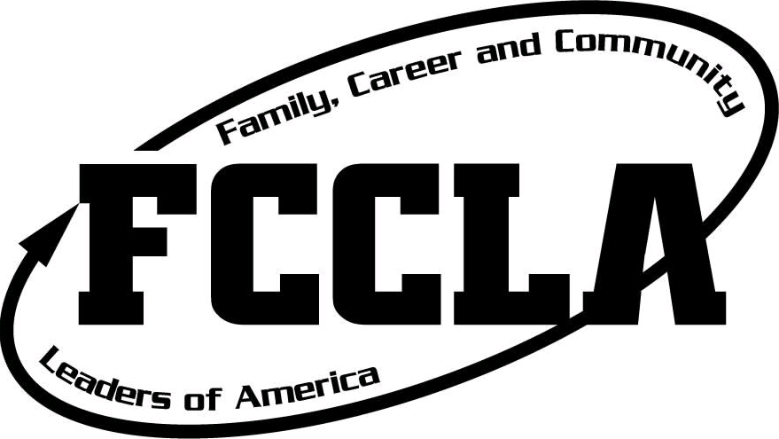
Utah FCCLA Region 4 Conference
Tuesday February 2, 2027
Nebo Summit Center
165 S. 700 E. Springville, UT. 84663
Schedule for STAR Event Competitors | Registration: 9:00-9:30  Opening Session: 9:30-9:45  STAR Events: 10:00-1:15  Lunch: 12:30-1:30  Door Prizes (Must be present to win) 1:30-1:45  Recognition, Closing Session: 1:45-2:30
Schedule for Judges & Room Consultants | Check in: 8:30-8:45 am  Judges Breakfast: 8:45-9:15  Judges Meeting: 9:15-9:45  Judges Prep Time: 9:45-10:00  Judging STAR Events: 10:00-1:15  Lunch: 12:30-1:30
Door Prizes | - Each chapter please bring a door prize.
Culinary Arts & Baking/Pastry Competitions | - Both the Culinary Arts and Baking & Pastry competitions will be held at Salem Hills High School on January 25th (subject to change). Competition time will be determined once we know who is competing.  - Culinary Arts & Baking/Pastry competitions are run as individual events, not teams. State competition will follow the guidelines for the national competition.  - Each chapter is allowed two individual competitors for Culinary Arts, and one competitor for Baking and Pastry.  - All students competing in these events at region will take an industry assessment on January 28-29.  - All competitors must be accompanied by an adult (parent or adviser). This includes students that are 18.  - The top two scores per region will advance to state.  - In the case that not all regions statewide have two participants to advance, the top test scores across the state will be used to select an alternative to fill the spot to compete at state.  - Advisers who plan to have competitors in these events should make sure to read the events overview sheet, menus, and equipment lists that will be sent out by Daphne Stockdale in December. This information will also be on the Utah FCCLA website.  - If you anticipate having competitors in either Baking & Pastry or Culinary Arts, please email Troy Chilcott (troy.chilcott@nebo.edu) & Kelsey Chappell (region4@utahfccla.org), so that we can have an estimated count of participants. (This does not replace online registration, however it is beneficial for planning.)
Testing Events  (Parli, Baking & Pastry, and Culinary Arts) | - Testing will use an online platform associated with Nationals called AnswerWrite. The testing site will be open on January 28-29 from 7:00 am to 10 pm. During this time frame you must have all individuals on a team schedule a time to take it the same time whether at home or in person.  - Everyone taking the test will need a proctor. Each participant must have a proctor form (will be sent out when registration closes)  - The testing tickets will be sent out before the testing window. It has urls for students to follow, username, and the password students will use. Please remind students and proctors that testing materials should be kept confidential during and after testing. Participants should only see test questions and are not to discuss them afterwards. If you have any other questions please let me know.
How to Register | - Region Conference registration is done through the DLG Registration System.  - This is the same registration system used for all Utah FCCLA conferences.  - Please contact me with registration questions.  - Please fill out registration completely, and remember to list those competing as a team together, all under the same team number.  - If a student is competing individually, they are still registered as a ‘team’ but they are the only member of that team.  - Here is the registration website: https://www.registermychapter.com/fccla/ut-r4/Main.asp
Cost, Payment, & Registration Deadlines | - Registration is $25 per person, submitted and must be postmarked by Friday, January 15 at midnight.  - Late registration received Jan. 17- Jan. 21 will be $30 per person.  - Advisers cannot make any changes to registration after January 22.  - No additional students will be allowed to attend if they are not registered by the late registration deadline- January 21 at Midnight.  - If you pay with a credit card, there is a 4% fee added to your registration.  - If you pay by check, please make the check out to Utah FCCLA.  - Please mail all checks to:  Utah FCCLA Region 4  ℅ Brendan Abbott  P.O. Box 162  Vineyard, UT 84059
Competition Levels | - Please make sure you double check the correct competition level. Students should compete on the same level they are affiliated with at Nationals.  - Levels:  - Level 1: 6-8th Grades  - Level 2: 9-10th Grades  - Level 3: 11-12th Grades  - Teams with members from different levels must compete in the higher level.
Dress Code | - Students should follow the FCCLA dress code for the entire conference. Students will be evaluated on the following dress code.  - Dress code:  - Top: Red, black, white, or khaki button up or polo  - Bottom: Black skirt or dress pants  - Black Sheath dress  - Closed toed shoes  - No jeans, leggings, tennis shoes, flip flops, etc.  - Adviser dress code is business casual.  - Our students watch us, please be the example!
Lunch | - Lunch will be served at the Summit Center for all students, advisers, judges, and room consultants.
Forms | - Each student must sign and return the FCCLA Code of Conduct form as well as permission form from your district giving parent permission to attend the conference.  - Please follow your district’s travel policy for liability issues and have all forms completed before leaving school.  - Students are not allowed to drive themselves to the conference.
Adviser Assignments | - Every school should sign up to run at least one event. This includes delegating a room consultant, and recruiting judges for the assigned event.  - Advisers, please watch for an email with reminders about Room Consultant assignments.  - Each judge must have a laptop or other device (not a cell phone) for judging.  - I will notify all room consultants of numbers as soon as registration is closed to get a more accurate count of how many judges are needed, but for now plan on at least 2 judges per event.
Make it to State! | - Students do not advance to state unless they have scored 70 points or higher at region.  - Please follow the STAR Events manual carefully and completely. The STAR Event Guide is available in the FCCLA Portal.  - The STAR Events Online Project Summary Form is now available in the FCCLA Portal under the ‘surveys’ tab.  - The State Conference is March 23-24; mark your calendars!

