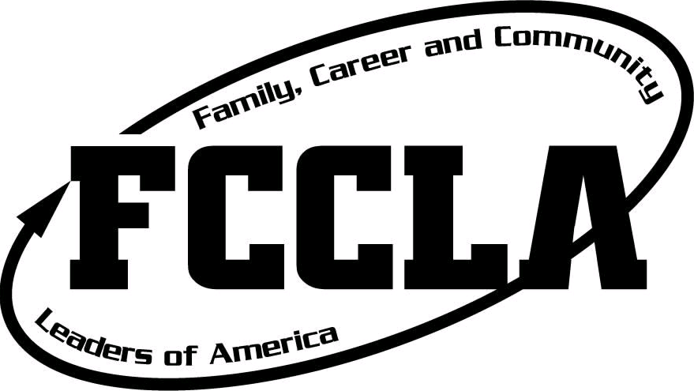
Region 5 Conference

Date: Tuesday, February 5, 2019
Location: Southern Utah University,
Hunter Conference Center
Time: 8:00 am – 1:30 pm
Cost: $12.00 Late registration fee of $17.00
Registration Deadline: Monday January 21, 2019

8:00-8:30am Registration (I will have name tags printed for you)
8:10-8:30am Judges Orientation
8:30-9:00am Opening Session
9:10-12:30pm STAR Events
12:45-1:30pm Closing Session/Awards ceremony

- Please fill out the registration form and email it postmarked by Monday January 21, 2019. Email to Joni Taft @ joni.taft@waynesd.org
- Area STAR Event registration must be done electronically through DLG. Just like you registered for Leadership. I will receive a notification that you have registered. Please make the deadline. Questions please let me know. This is the website for registration, the link can also be found on the Utah FCCLA Website. https://www.registermychapter.com/fccla/ut-r5
- All students, advisors, and chaperones who are attending need to register, even if they are not competing in a STAR event. You do not need to register your adult judges.
- Please fill out the registration information completely and remember to list those who are competing as a team together. If you have students competing as a team in culinary they are all team 1; if there are 2 teams competing in focus on children the first group would be team 1 and the other group competing in focus on children would be team 2.
- Students need to be affiliated and invoices paid for affiliation before you can register them so please plan accordingly. If you have affiliated your students please double check to see if you have paid for them. Once in your National FCCLA account you can see if your affiliation is complete. If it is not complete there will be a RED TAB that says “submit affiliation”. If you try to register a student at DLG who is grayed out that means they have not been paid for through Nationals, and you must go back to the National Affiliation and pay for that student. Credit card payments for affiliation will allow you to register immediately. If you are paying affiliation by check or PO you will not be able to register until National FCCLA Headquarters has received the payment.
- This system times out after 20 minutes, so when you are registering students set aside the time needed to focus on this!

- Your online registration must be completed by January 21th 2019. Payment must also be postmarked by January 21th to avoid a late fee charge. Late Registrations will be accepted from January 22nd until January 25th with a $5 late Fee.
Please send payment to:
Utah FCCLA
c/o Joni Taft
Wayne High School
Bicknell, Utah 84715
Checks need to be made out to Utah FCCLA for the total amount. If you are using the credit card payment option a 4% fee will be charged. You must also fill out a credit card authorization form that can be found on the Utah FCCLA website.
Payment must be postmarked by January 21, 2019 with an additional $5
Cost is $12 per student, advisor, and chaperone. ( Not judges)
If you have any problems or questions, email Joni Taft at joni.taft@waynesd.org or phone at 435-691-0632 cell). If you have other teachers or advisors needing this information, please forward me his/her email address so I can add him/her to the Region 5 contact list.

- Request a check to be made out to Utah FCCLA for the total amount. This year, regular registration is $12.00 per person. Late registration will be $17.00 until Friday January 25th No registrations will be accepted after this date. Students will not be able to participate if their teacher sends their registration in late. Please remember to include the adviser registration fees & names as well.

- Please make sure you have affiliated all students correctly since DLG is linked to the national website.

- Please follow the STAR events manual carefully. These guidelines are there to help you and your students. The STAR event manual can be found on the FCCLA website, but you need to be affiliated to have access. Also, check out the resource section it is very helpful.

- We will need your help again this year in running STAR Events. Each Adviser will be in charge of an event(s) and act as a room consultant again this year. You will need to recruit 3-6 judges for your assigned STAR Event. You may use Seniors in high school, but remember that we need to have 2 adults for every student. Please let me know how many judges you are bringing.

- Culinary recipe has already been sent and equipment list has been sent.

- If you would like a letter to give to your judges let me know. Please try to orient yourself and your judges to the rubrics for your events before we get there.

- Reminders:
- Once a student is affiliated as occupational, they remain occupational in all other affiliations throughout high school.
- Help your students make it to state!
- Students will NOT ADVANCE to state in March if they do not have a score of 50 points or higher.
- A member must first compete in person at a Region competition to qualify for competition at the state conference.
- A member must compete in the same event at Region and State
- A member may only compete in one STAR event per year.
- A member must receive a score of 50 or above at Region in order to compete at State.
- A member may compete in the same event every other year in Foundational and Leadership STAR Events.
- A member may compete in the same event every year in Career Preparation STAR Events.
- The State has a rubric for scoring the students dress. Please share with your students.

