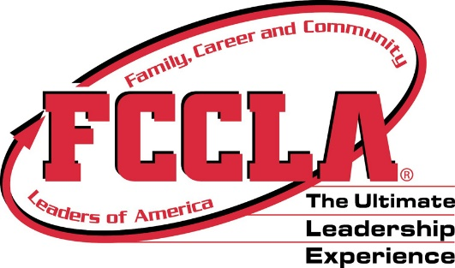 |  | FCCLA Dress Code  Rubric
 |  | Every STAR Event is a little different when considering how it will implement professional dress code during event. Please make sure you know as an evaluator where these points come in on your STAR Event. Use the following Utah State Dress Code Guidelines to help you compete it best you can. You may need to average scores and adjust to fit within your event guidelines.
Professional Dress
Clothing & Appearance | 0  Non-professional appearance, attire and/or grooming.  (See below) |  |  | 1  Neat professional appearance, attire and grooming, but lacks all of set requirements. (See below) |  | 2  Professional appearance, attire, and grooming. The Utah FCCLA Dress Code has been met. (See below)
Tops | Examples:  T Shirts, sweatshirts, tank tops, and other non-appropriate tops |  |  | Examples:  Small exemptions to rules like; solid colored shirt but not collared, or collared shirts with large or small patterns |  | Expectations:  Red, black or white oxford or polo (collared) shirt; solid colors, no patterns; can be long or short sleeves
Bottoms | Examples:  Jeans, capris, shorts, athletic wear, leggings, and other non- appropriate bottoms |  |  | Examples:  Small exemptions to rules like; skirts pushing limits of no shorter than 2 inches above the knee. |  | Expectations:  Black solid dress bottoms. Can be dress slacks or skirts. Must be no shorter than 2 inches above the knee.
Shoes | Examples:  Tennis shoes, slippers, flip flops, and other non-appropriate shoes. |  |  | Examples:  Small exemptions to rules like black boots. |  | Expectations:  Dress Shoes  (black preferred)
Costumes
Must be allowed on Event Guidelines | 0  Event does not allow for costumes to be worn or the costume does not meet normal School Dress Code |  |  | 1  Costume is allowed for event but does not enhance the overall presentation or is distracting. |  | 2  Costume enhances overall presentation, follows an industry expectation (Culinary Arts), and matches the themes of the presentation.

